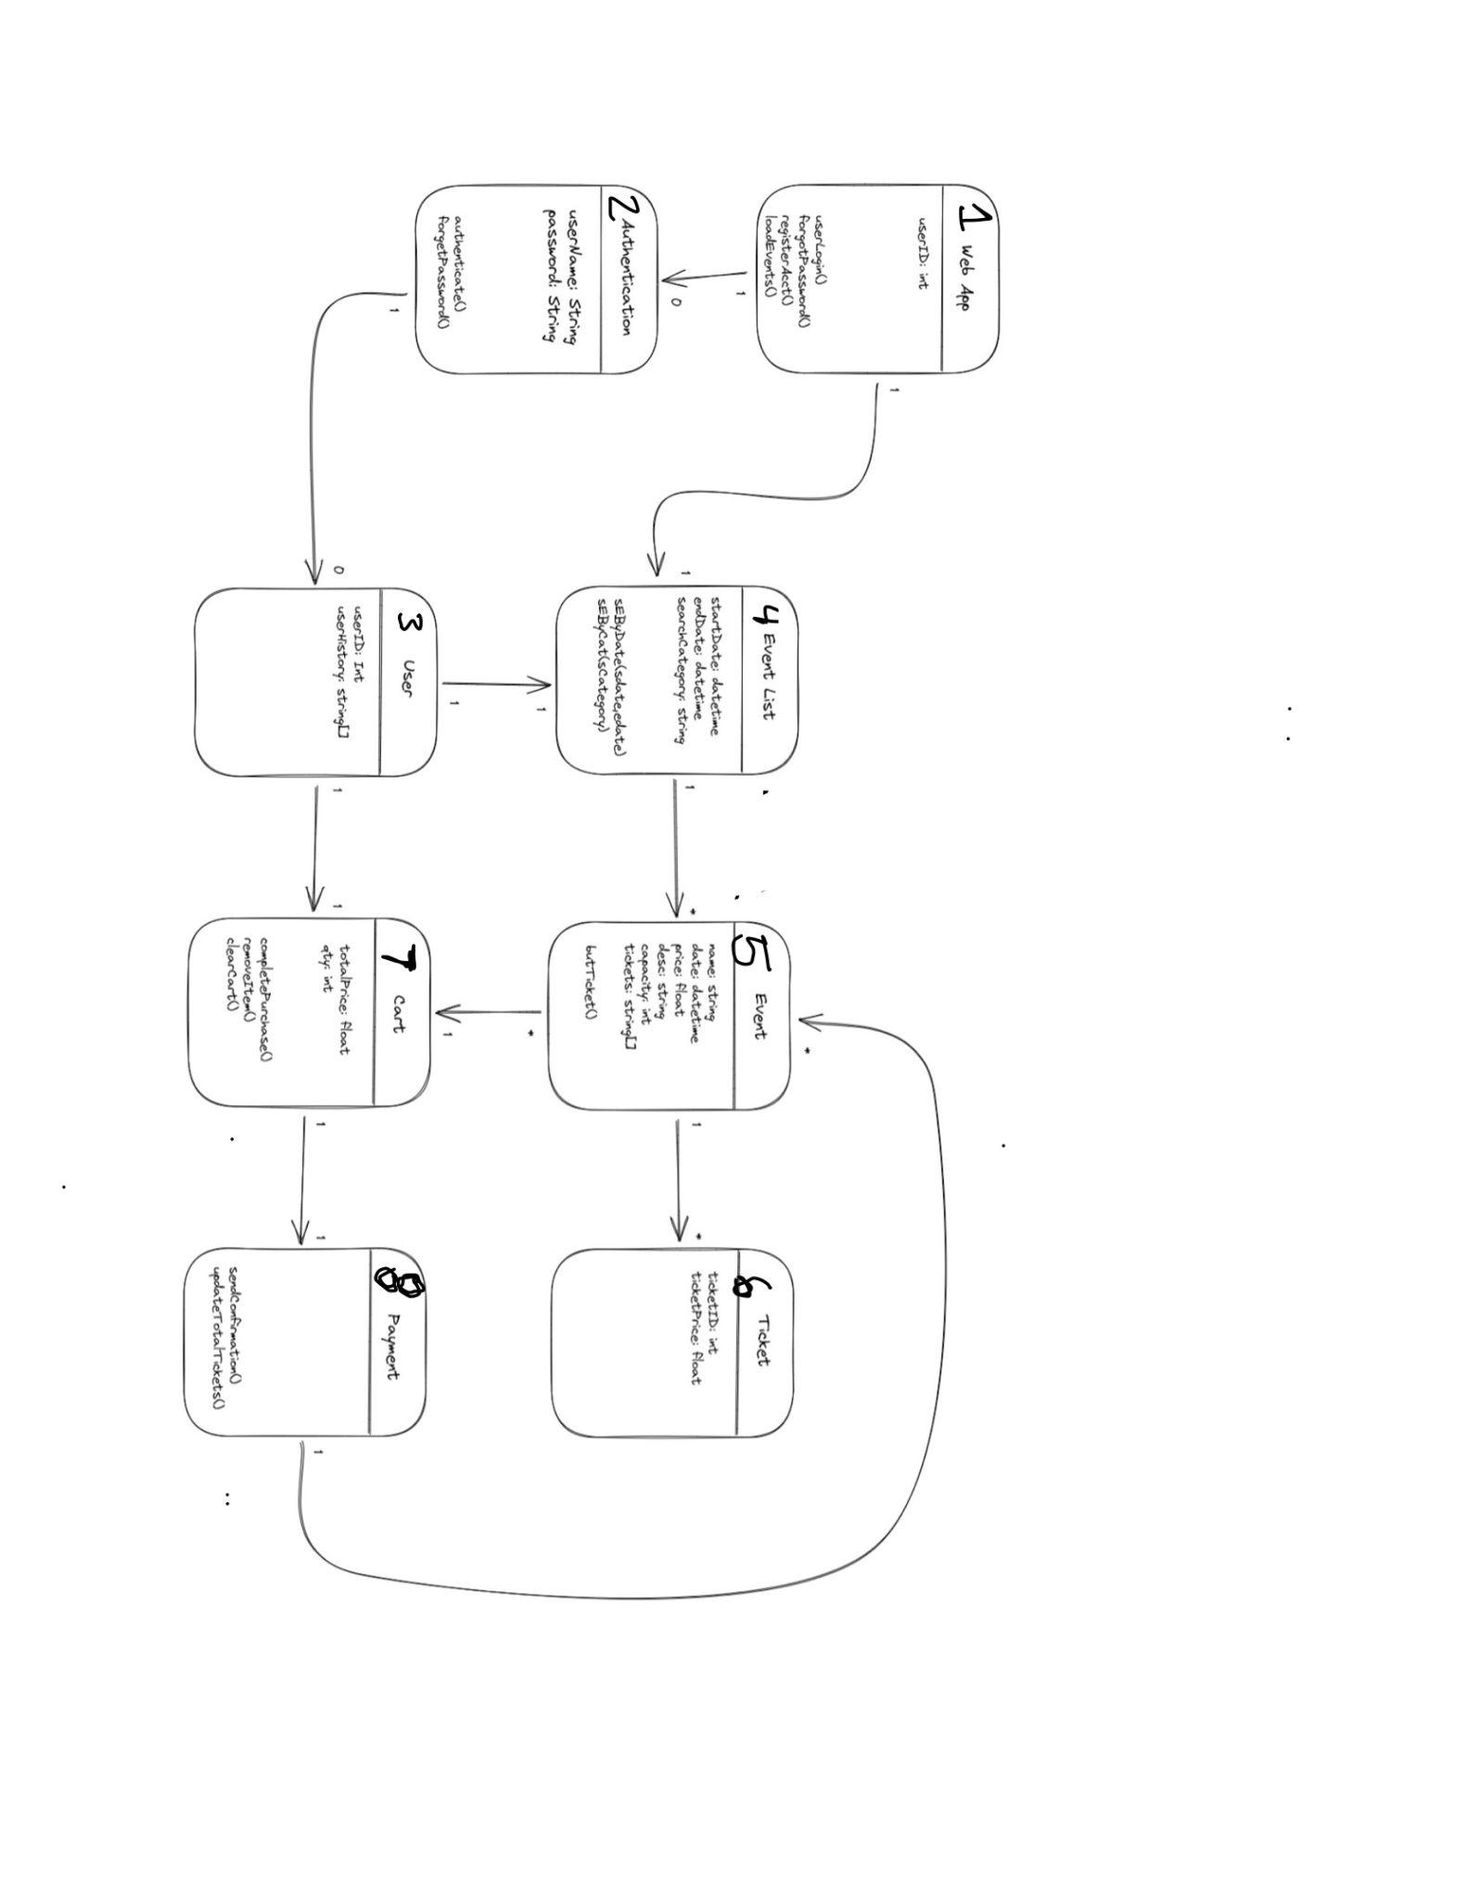

|  |  |  |
| --- | --- | --- |
| Object | Responsibilities(Knowing) | Responsibilities(Doing) |
| Web App | User ID | User login  Forgot Password  Making account  Loading Events |
| Authentication | User name  Password | Authenticate information |
| Event List | Start date  End date  Search categories |  |
| User | User id  User history |  |
| Event | Name  Date  Price  Description  Capacity  tickets | Buy tickets |
| Cart | Total pice  amount | Complete purchase  Remove item  Clear cart |
| Ticket | Ticket id  Ticket price |  |
| {ayment |  | Send confirmation  Update total tickets |

User:

int: userID;

string: userHistory[]

constructor(userID, userHistory[]);

EventList:

string: startDate;

string: endDate;

string: searchCategory;

Func: SEbyDate(startDate, endDate);

Func: SEbyCat(searchCategory;

Event:

string: name;

string: dateTime;

float: price;

string: desc; // description

int: Capacity;

string[]: tickets[];

constructor(name, dateTime, price, desc, capacity, tickets[]);

Func: buyTickets();

Ticket:

int: ticketID;

float: ticketPrice;

Constructor(ticketID, ticketPrice)

Authentication:

string: userName;

string: password;

Func: authenticate(userName, password)

Func: forgetPassword()

Cart:

float: totalPrice;

int: quantity;

Constructor(totalPrice, quantity)

Func: confirmation();

Func: removeItem();

Func: clearCart();

Payment Confirmation:

float: totalPrice;

Func: completePurchase();

Payment:

Func: sendConfirmation();

Func: updateTotalTickets();